12. Plot of Slickenside Planes and Striations

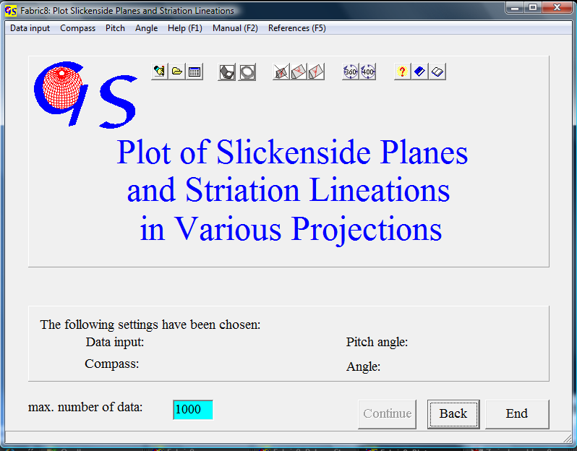
Fig. 1

This program (Fig. 1) plots slickenside planes and striations on them. The starting form and data input is identical with program 11.
The slickenside plane are plotted as great circles. The striation is plotted as a dot on the great circle. The sense of movement is marked by an arrow which indicates the movement of the hanging block. Measure errors are corrected. After this correction the striation lineation always lies exactly on the great circle Fig. 2 shows the graphic form for the data set used in program 11.

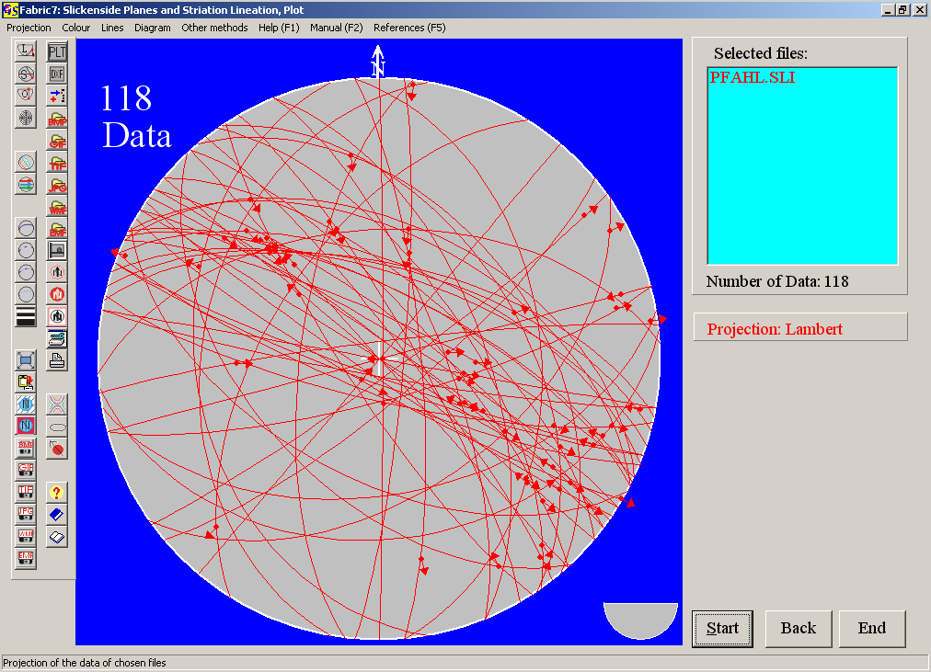Fig. 2

The projection method is chosen in the menu "Projection”.
The menu is described in program 3.
With the menu "Other methods" you can jump to the other programs which use displacement data.

